# Figures Legends

figure 1| Barrett’s esophagus patient flow chart for the HGD strategy. Additional charts for the treatment strategies can be found in the appendix.

figure 2| Figure 2 a shows the EAC incidence per 1000 BE patients per model and strategy (no discounting). Figure 2b shows the EAC deaths per 1000 BE patients. The EAC incidence and mortality reductions are shown for the endoscopic eradicative treatment strategies compared to the strategy including only surveillance and no endoscopic eradicative treatment. The range in model estimates reflects differences in model structures and assumptions on BE prevalence and time to development of malignancy.

figure 3| Mortality reduction compared to the total number of treatments per model and strategy (no discounting).

**Figure 1|** BE patient flow diagram for strategy HGD

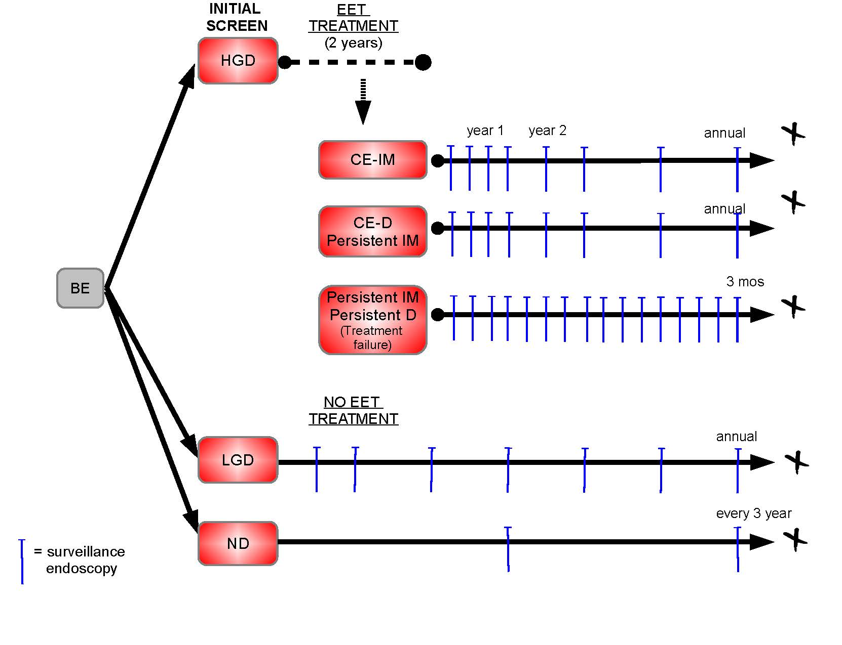

HGD: High-grade dysplasia, LGD: Low-grade dysplasia, ND: No dysplasia, CE: Complete eradication, IM: Intestinal metaplasia (BE ND), D: High or Low grade dysplasia, EET: Endoscopic eradication therapy. Strategy HGD: Endoscopic ablative therapy for HGD diagnosed patients strategy

**figure 2**| EAC incidence and EAC mortality

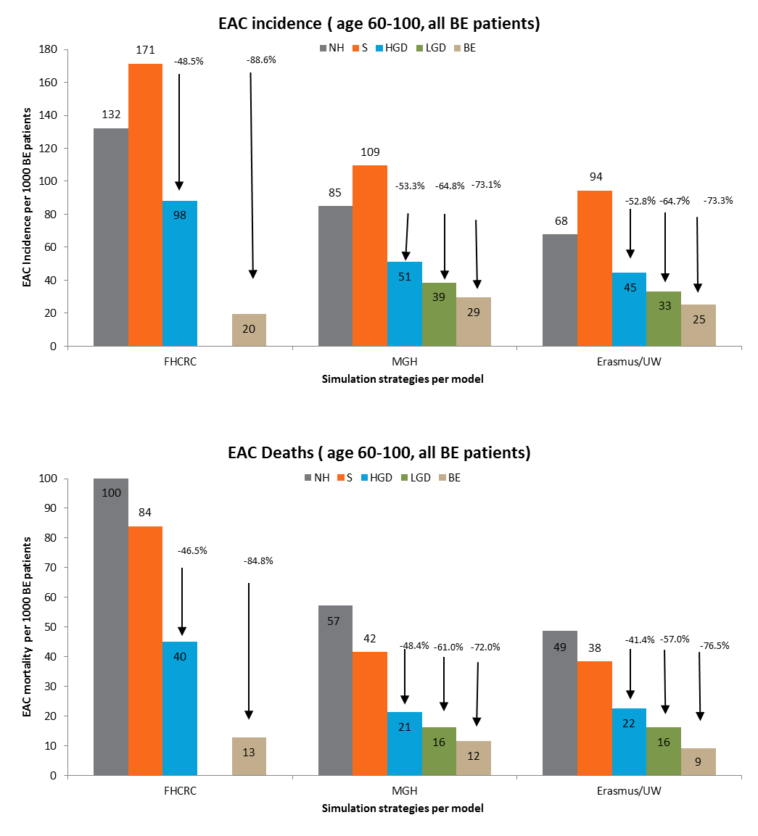

EAC: Esophageal adenocarcinoma, FHCRC: Fred Hutch Cancer Research Center model: MGH: Massachusetts General Hospital model, Erasmus/UW: Erasmus/University Washington model, Strategies: NH: Natural history (no interventions), S: Endoscopic surveillance for all diagnosed BE patients, HGD: Endoscopic ablative therapy for HGD diagnosed patients, LGD: Endoscopic ablative therapy for LGD and HGD diagnosed patients, BE: Endoscopic ablative therapy for all diagnosed BE patients.

**figure 3**| Mortality reduction compared to the total number of treatments per model and strategy (no discounting).

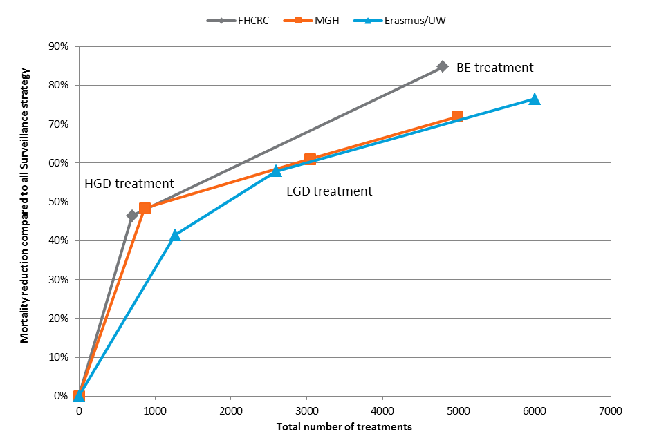

FHCRC: Fred Hutch Cancer Research Center model: MGH: Massachusetts General Hospital model, Erasmus/UW: Erasmus/University Washington model, Strategies: HGD: Endoscopic ablative therapy for HGD diagnosed patients, LGD: Endoscopic ablative therapy for LGD and HGD diagnosed patients, BE: Endoscopic ablative therapy for all diagnosed BE patients.